Project: Pizza Sales Analysis

- This project analyzes pizza sales data to identify sales trends, customer preferences, and revenue performance. It uses SQL for data cleaning and analysis, and Tableau for visualization and dashboard creation.
Objective:
The main objective of this project is to analyze pizza sales data to identify:
- Which pizzas sell the most and least.
- Overall sales trends and business insights.
- .Most popular sizes and categories understand customer
By analyzing these factors, we can help the pizza restaurant improve sales performance, staff scheduling and inventory planning

Tools Used:
- SQL- Used foe data cleaning, aggregation, and analysis of pizza sales data.
- Tableau: Used for creating interactive dashboards and visual insights.
- MS Excel / CSV: Used for storing, preparing and importing data.

Dataset Description:
The dataset used for this project contains detailed information about pizza sales from a pizza restaurant. It includes data about pizza categories, sizes, names, prices, quantities, and order dates. The dataset contains a total of 48,620 rows and 12 columns.
Key Columns in the Dataset:
Column Name | Description
Order_id | Unique ID assigned to each customer order
Order_date | Date on which the pizza order was placed
Order_time | Time at which the order was placed
Pizza_id | Unique ID for each pizza item
Pizza_name | Name of the pizza(e.g.,The Classic Deluxe Pizza)
Pizza_category | Type pf pizza (Classic, Veggie, Supreme, etc.)
Pizza_size | Size of the pizza (S, M, L, XL, XXL)
quantity | Number of pizzas ordered
unit_price | Price per pizza
total_price | Total cost for that order line (unit price * quantity)
Pizza_ingredients | Ingredients used in the pizza

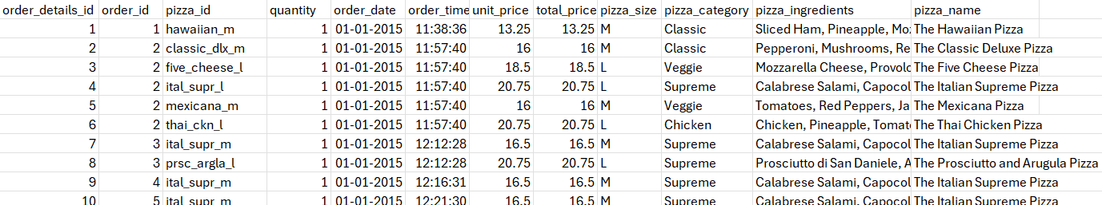

Data Cleaning:
- Before performing analysis, I checked and cleaned the pizza sales data using SQL queries.
- I verified the total number of rows, checked for null or missing values, and removed duplicate records.
- After cleaning , the dataset was ready for doing SQL queries and creating visualization in Tableau.
- Check for Missing and Null values
SELECT SUM(CASE WHEN order_id IS NULL THEN 1 ELSE 0 END) AS missing_order_id, SUM(CASE WHEN pizza_name IS NULL THEN 1 ELSE 0 END) AS missing_pizza_name, SUM(CASE WHEN total_price IS NULL THEN 1 ELSE 0 END) AS missing_total_price FROM pizza_data;
This identifies if there are any missing or null values in key columns.
- Remove Duplicates
select distinct * from pizza_data;
Ensures only unique records are used for analysis.
- Verify date and time format
SELECT order_date, order_time, DATE_FORMAT(order_date, '%Y-%m-%d') AS formatted_date, TIME_FORMAT(order_time, '%H:%i:%s') AS formatted_time FROM pizza_data LIMIT 10;
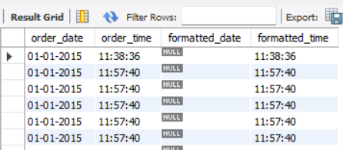

SQl Queries for Data Analysis:
After cleaning the data, I used different SQL queries to find useful information from the pizza sales dataset.
These queries helped me calculate total revenue, no.of orders, top and bottom pizzas, and sales trends by category, size, and time.
1.Total Revenue
SELECT SUM(total_price) AS total_revenue FROM pizza_data;
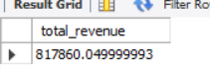
2.Total Orders
SELECT SUM(order_id) AS total_orders FROM pizza_sales;
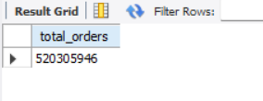
3.Total Pizza Sold
SELECT SUM(quantity) AS total_pizza_sold FROM pizza_data;
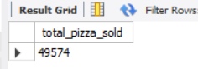
- Average Order Value
SELECT SUM(total_price)/COUNT(DISTINCT(order_id)) AS average_orders FROM pizza_data;
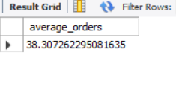
- Percentage of Total Revenue by Pizza Category
SELECT pizza_category, ROUND(SUM(total_price) * 100 / (SELECT SUM(total_price) FROM pizza_data), 2) AS revenue_percentage FROM pizza_data GROUP BY pizza_category ORDER BY revenue_percentage DESC;
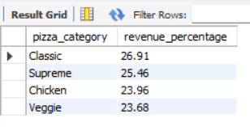
6.Revenue Contribution by pizza Size
SELECT pizza_size, SUM(total_price) AS total_revenue, ROUND(SUM(total_price) * 100 / (SELECT SUM(total_price) FROM pizza_data), 2) AS revenue_percentage FROM pizza_data GROUP BY pizza_size ORDER BY total_revenue DESC;
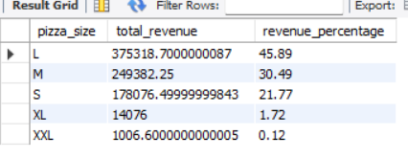
7.Monthly Total Revenue Over Time
SELECT MONTHNAME(order_date) AS month_name, SUM(total_price) AS monthly_revenue FROM pizza_data GROUP BY MONTH(order_date), MONTHNAME(order_date) ORDER BY MIN(order_date);
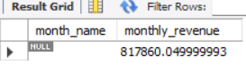
8.Top 10 Pizzas by Total Revenue
SELECT pizza_name, SUM(total_price) AS total_revenue FROM pizza_data GROUP BY pizza_name ORDER BY total_revenue DESC LIMIT 10;
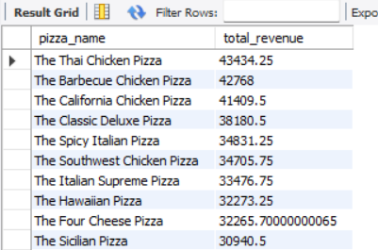
9.Bottom 10 Pizzas by Total Revenue
SELECT pizza_name, SUM(total_price) AS Total_Revenue FROM pizza_sales GROUP BY pizza_name ORDER BYTotal_Revenue ASC LIMIT10;
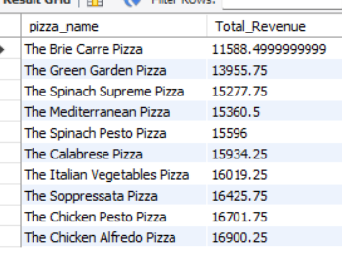
10.Top 5 Pizzas by Total Orders
SELECT pizza_name, COUNT(DISTINCT(order_id)) AS total_orders FROM pizza_data GROUP BY pizza_name ORDER BY total_orders DESC LIMIT 5;
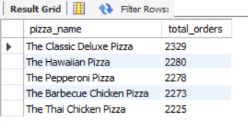
11.Bottom 5 pizzas by Total Orders
SELECT pizza_name, COUNT(DISTINCT(order_id)) AS total_orders FROM pizza_data GROUP BY pizza_name ORDER BY total_orders ASC LIMIT 5;

12.Most Popular Pizza Category by Size
SELECT pizza_category, pizza_size, SUM(quantity) AS total_sold FROM pizza_data GROUP BY pizza_category, pizza_size ORDER BY total_sold DESC;
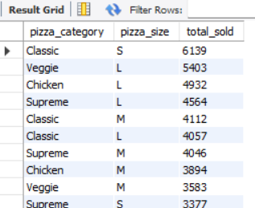
13.Total Revenue & No.of Orders by Weekday
SELECT DAYNAME(order_date) AS weekday_name, SUM(total_price) AS total_revenue, COUNT(DISTINCT order_id) AS total_orders FROM pizza_data GROUP BY weekday_name ORDER BY FIELD(weekday_name, 'Monday', 'Tuesday', 'Wednesday', 'Thursday', 'Friday', 'Saturday', 'Sunday');
14.Total Revenue by Pizza Category
SELECT pizza_category, SUM(total_price) AS total_revenue FROM pizza_data GROUP BY pizza_category ORDER BY total_revenue DESC;
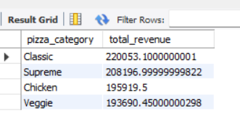

Data Visualization using Tableau:
I used Tableau to create visual dashboards from the cleaned pizza sales data.
These dashboards help to clearly understand the sales performance, order trends, and revenue contribution of each pizza category and size.
The visualizations make it easier to identify top and bottom selling pizzas, most preferred pizza sizes, and sales patterns across months and weekdays.
By using different charts types such as pie charts, bar charts, line charts, and KPIs, I was able to present overall business insights in a clear and interactive way.
These Tableau dashboards give a complete picture of the pizza stor’s performance and help in making data-driven decisions.
- Dashboard 1 shows total KPIs, monthly trends & top/bottom pizzas by revenue
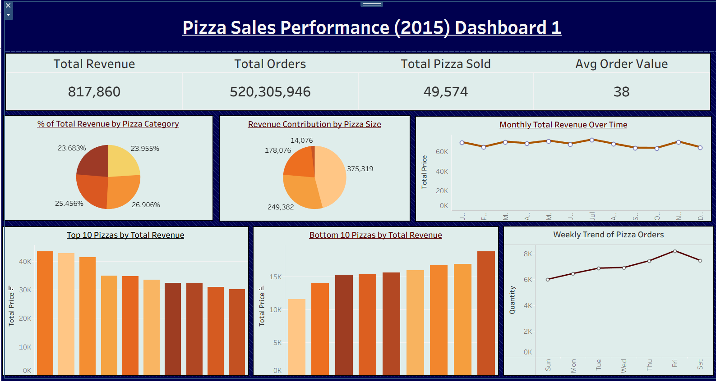
- Dashboard 2 focuses on top/bottom pizzas by orders & category-wise performance
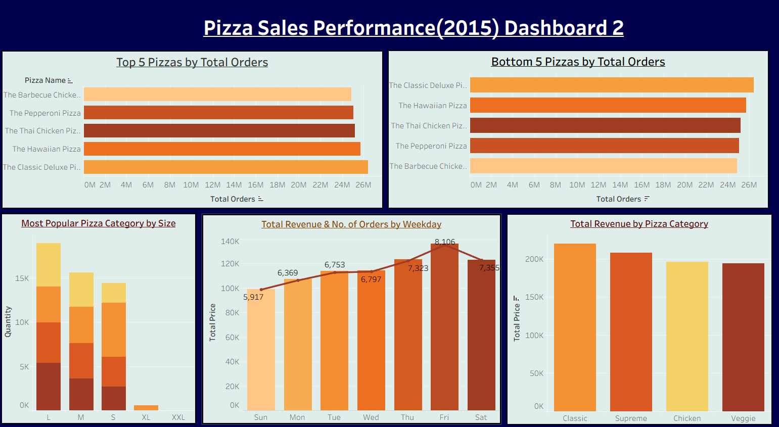
Key Insights:
- From the pizza sales analysis, the total revenue generated was 8,17,860, with around 49,574 pizza sold.
- The monthly trend shows a steady performance throughout the year, with a slight increase in the middle months.
- The top 1 pizzas brought in most of the revenue, while the bottom 10 pizzas contributed less, indicating customer preference.
- The weekly trend highlights that Friday and Saturday are the busiest days for pizza orders.
Overall, the analysis helps understand which pizza types and sizes perform best and when sales are highest.
Conclusion:
This project helped me understand how to use SQL for data cleaning and analysis, and how to create dashboards in Tableau to visualize insights.
From the pizza sales data, I identified revenue trends, popular pizza categories, and weekly order patterns.
This project improved my data analysis and visualization skills, and showed how data can help in making better business decisions.

